**Call time:** March 5, 4:00 - 5:00 pm UTC ([see in your time zone](https://arewemeetingyet.com/UTC/2020-03-05/16:00/Open%20Hardware%20Leaders%20-%20Week%204%20Cohort%20Call#eyJ1cmwiOiJodHRwczovL3pvb20udXMvai80MDAzODYyNiJ9))

**Hosts**:Alexander, José

**Syllabus:** [**Week 4**](https://openhardware4.me/Program/11_Week4.html)

#### Joining the call

To **JOIN THE CALL** (using Zoom): [https://zoom.us/j/40038626](https://zoom.us/j/400386261)

* Please note that this call will be recorded
* The video will be available on the [YouTube channel](https://www.youtube.com/channel/UCOSSTT7wiqa9tndiulBja1A?view_as=subscriber) in the next days
* Turn on your webcam if you don’t mind sharing your face (or off if you do!)

#### This week

In this first cohort call you will share this work with your peer mentees. Through different exercises you will get a fresh, external look on what you’ve been doing, which will give you useful insight for the next weeks.

#### Before this meeting

Prepare a max 5’ pitch based on what you've seen in weeks 1, 2 and 3. It must include:

* Your value proposition (week 1),
* at least one persona & pathway (week 2),
* at least one identified assumptions and its proposed test (week 3).

#### Roll call

* Alex / @alexwastooshort (twitter) / Munich, Germany
* Jose Carlos Urra / github: jurra / now in Netherlands, Delft
* Alejo / LoRa data loggers for environmental quality (EcoSen) /Córdoba, Argentina
* Camilo / @cparrapa / @OttoDIY / Czech Republic
* Barbora, Benedict, René / UC2 / twitter: @openUc2 / useetoo.org / [github.com/bionanoimaging/UC2-GIT](https://github.com/bionanoimaging/UC2-GIT) / Jena, Germany
* Gonzalo Vidal / Corchea / @Gonzalo0V (twitter) / Santiago, Chile
* Salman Faris/ River Monitorng system( Open-RiMo)/@0xSalfar(twitter) / Kochi, India.

#### Welcome!

Alexander (⏰ 2 min)

* Reminder: [Community participation guidelines](https://openhardware4.me/open-hardware-leaders.github.io/Program/04_community.html)
* If you experience or witness unacceptable behaviour, or have any other concerns, please contact the organizers ([openhardware4me@gmail.com](mailto:openhardware4me@gmail.com)).

Cohort call goals

José (⏰ 3 min)

* Familiarize yourself with exposing your work
* Get useful feedback to continue working on your project
* Provide other participants with useful feedback for their projects

Peer review pitches

*Each mentee has 5 minutes to pitch. Fellows write down questions/comments, which are addressed afterwards (another 5’).*

### 

### Open River Monitoring System: RiMo

*Mentee: Salman Faris*

* 5’ pitch
* Fellows, write your questions / comments here:
  + 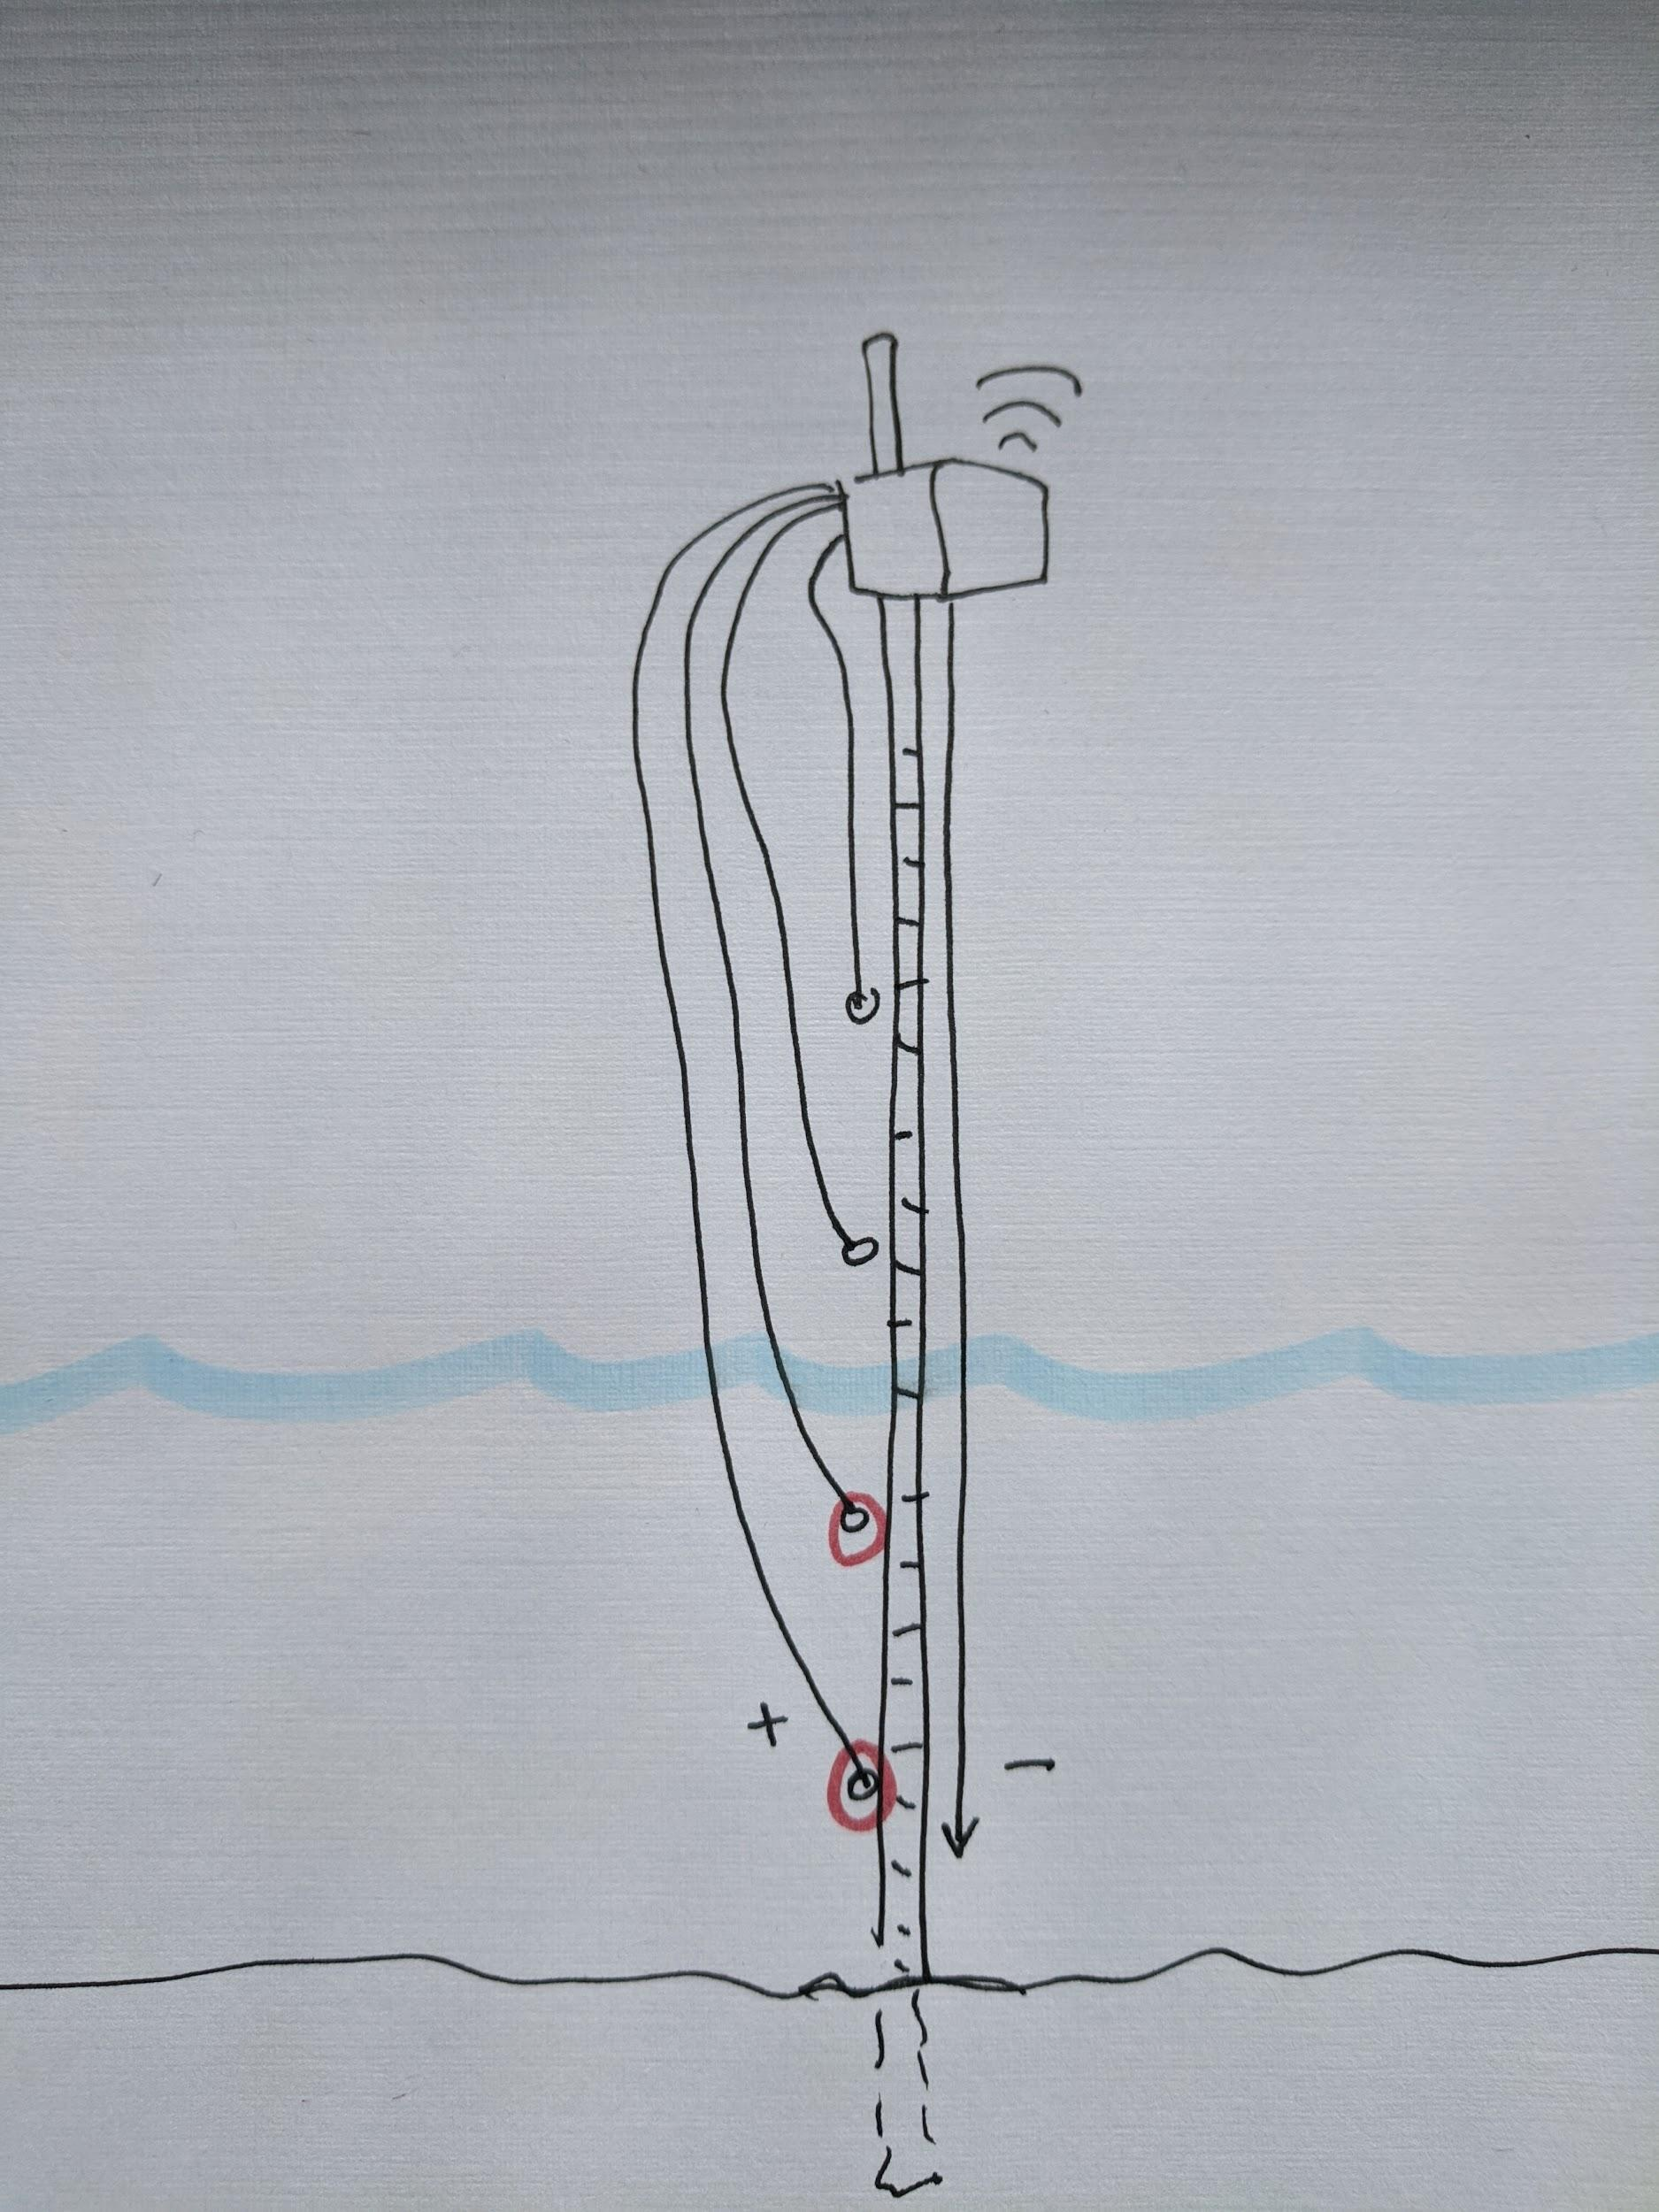
  + Jeff: Are there some existing systems for compiling data from across the network, and is it presented in a way that works for the intended audience (say, does it load on a phone, maybe?)
    - What happens in cases of false alarms?
    - Could a series of wires at different levels on a meter stick work to cheaply detect water level? See drawing to right side:
    - <https://publiclab.org/wiki/water-sensors#Choosing+Sensors>
  + Alex: What about the user channel?
* Discussion (5’)

### LoRa Data Loggers for environmental quality

*Mentee: Alejo Bonifacio*

* 5’ pitch
* Fellows, write your questions / comments here:
  + Alex: Do you plan to involve citizen scientists?
* Discussion (5’)
  + What hardware has been implemented or planned to be implemented?
  + Alex: citizen science? Alejo says that focus is on scientists
  + Salman: What kind of sensor are you using ?
  + Gonzalo: Why are these sensors relevant?
  + Hello Gonzalo: These data loggers are important to monitoring the environmental degradation.
  + Camilo: good idea do you know <https://smartcitizen.me/>?
  + Jeff: Public Lab has a long list of water sensors here (not necessarily comprehensive but already long!): <https://publiclab.org/wiki/water-sensors#Choosing+Sensors> if helpful!
    - Feel free to add to the list too
    - It has prices, sensitivity limits, etc
    - Alejo: Thanks a lot for the information I am gonna check the list!!!

### Otto DIY

*Mentee: Camilo Parra*

* 5’ pitch
* Fellows, write your questions / comments here:
  + Jose: Are you familiar with the printbots concept? **Yes great inspiration**
  + Alex: Thanks for all your effort and starting this program (I'm a STEM educator ad directly profiting from your work) **you are welcome :D**
  + Do you have start guides and tutorials in your website? **Yes for the basics**
  + Jeff: interesting strategy from the Public Lab Lego Spectrometer - it’s made of second-hand legos, but we also shared lego-compatible 3d-printable parts so that there’s a bridge between the lego community and the 3d-printing community. Could be an interesting strategy to choose one but not exclude the other if that’s attractive! <http://publiclab.org/lego>
    - “Leave the door ajar” strategy, via standard adapter interfaces **Great idea thanks**
    - ‘Lego obsession’ lol
  + Jeff: did I hear ~70? variants/remixes of the project exist already? Maybe i misheard but cool you’re thinking on this in either case! Is there a current user community for Otto? Thanks!

**Yes an join can join us** <https://wikifactory.com/+OttoDIY/projects>

* + Jeff: Cool project!!!
  + Alejo: beautiful project!
    - How many people are working on your project?
* Discussion (5’)

### Corchea

*Mentee: Gonzalo Vidal Pena*

* 5’ pitch
* Fellows, write your questions / comments here:
* Discussion (5’)

### UC2

Mentee: Barbora Maršíková

* 5’ pitch
* Fellows, write your questions / comments here:
  + Alejo: It has a very ingenious design!
  + Jeff: Love the super clear description: “arduino for optics”!
    - PL produces optical slits for collimation, how would we adapt our module to be compatible?
      * <https://store.publiclab.org/collections/spectrometry/products/lego-accessories?variant=14671323693165>
      * Also diffraction gratings: <https://store.publiclab.org/collections/spectrometry/products/lego-accessories?variant=14671323660397>
      * Does the standard have a name we could say “compatible with…” -- ah ok got it - “UC2 compatible” <https://github.com/bionanoimaging/UC2-GIT#uc2-as-an-open-standard>
      * B: Anything that fits a few given dimensions is generally compatible. Here’s our Modular Developer Kit: <https://github.com/bionanoimaging/UC2-GIT/tree/master/MDK>
        + Found this, awesome! 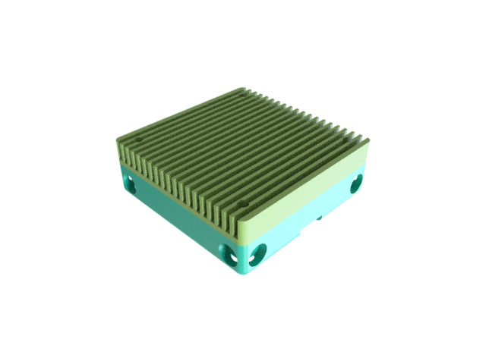
  + Alex: I have no idea about optics but the projects seems like it fills a gap in this specific community.
  + Alex: Seems like you have a great team! Keep up the good mood ;)
  + Camilo: Where can someone contribute to the design? Your project and readme is great, for hardware part of your project i highly recommend using wikifactory
    - B: I’ll have a look at the wikifactory. We’ve been using GitHub so far mostly because that’s where we started. Thanks for the suggestion!
  + Alex: Check out <http://openhardware.science/>
* UC2 pre-print <https://www.biorxiv.org/content/10.1101/2020.03.02.973073v1>
* Barbora: Thank you all for the great words of support!
* Discussion (5’)

#### 

#### Closing

Alex (⏰ 2 minutes)

*Quick overview of* [*week 5 activities*](https://openhardware4.me/open-hardware-leaders.github.io/Program/12_Week5.html)

* **Week 5 goals**
  + *Learn to prioritize and scope releases*
  + *Plan and start running a sprint based on your defined priorities*
* **Week 5 assignments**
  + Define the scope statement for your participation in the program
  + Prioritize your work based on feasibility and relevance, using the github project board
  + Decompose your test cards in achievable activities in a timeline (or tasks)
  + Move these tasks into the sprint backlog planning
* Next peer review - Week 8
  + Next cohort call: April 2, 4:00 - 5:00 pm UTC
* Reminder
  + [Riot chat](https://matrix.to/#/!hxevZqbsxnEcuYYQsy:matrix.org?via=matrix.org)
  + [Program schedule](https://openhardware4.me/open-hardware-leaders.github.io/Program/02_schedule.html)
* Open Q & A time

#### Feedback

What worked?



What didn’t work?



What would you change?



What surprised you?